How to use Willia Chat™

Willia Chat™ is the revolutionary new medium in which trendy teens can now communicate. A chat program of this caliber will be the first and the last of its kind. This program will enable members to chat away to each other until all hours of the morning (not advised).

**Table Of Contents**

Joining Willa Chat - (Page 1)

Navigating Willa Chat - (Page 2-3)

Using Emojis - (Page 3)

Joining Willia Chat™

When you launch Willia Chat™ you are presented with the screen below (without outlines) which ask you for a few pieces of information and give you 2 options. All of which will be explained in the pages that follow.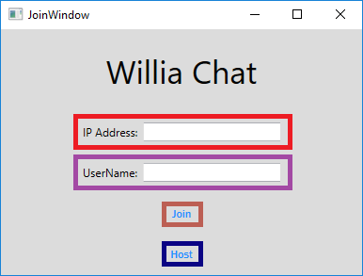

Red - The program requires an IP to join a Willlia chat server, this means the member that is hosting needs to distribute the IP. You may need to use ancient methods of communication (eg; imessage) to obtain the host’s ip. We apologize for this inconvenience. Input this hindu arabic sequence here.

Purple - The program requires that you also input a username, this name will be used to identify you once you have connected to a Willia server. Remember every connected member will see this so keep it PG.

Brown - This button requires both an IP address and a Username to function correctly. Once clicked a new screen will appear in which you can begin chatting away which will be described in the guide ahead.

Blue - NOTE - You must first port forward (see port forwarding tutorial that is associated with Willa Chat). This button launches the server, once launched you will need to distribute your IP to all other people desiring to join the server.

Navigating The Willia Chat™ Client

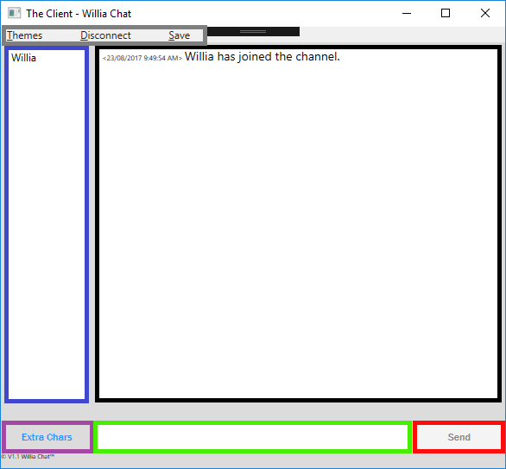

Red / Green - These two aspects go hand in hand, the green area is the text inputting area in which the user can type a message for the other connected clients to see. When the user has finished typing what they want to say they can click the send button, this red outlined area, all other connected clients will see this message.

Blue - This outlined area is the connected clients list, put simply any other connected clients will have their name in this box. Yours included.

Black - This area outlined in black contains all messages sent whilst you are connected to the server. It will show you the time in which it was sent and who sent the message.

Grey - This area is quite diverse. It has 3 sections that will be spoken about -

* Themes tab - There are many different themes offered by Willia chat, you can alter the theme by selecting a new theme in the themes tab. To return to default you can simply deselect the current theme you have selected and it will return to default. Only one theme can be selected at once.
* Disconnect Tab - Disconnects you from the server, meaning you will stop receiving messages and this window will close. NOTE if you disconnect, and you wish to save your conversation, you MUST save the conversation before disconnecting because the window will close thus removing the option to save.
* Save Tab - If at anytime you wish to save the chat you have just had with another user or users you can click the save button and you can elect to save it where you like and in what format you choose.

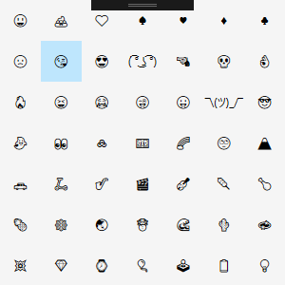

Purple - This is the extra characters window - Clicking this button will open a new window in which the client can select from a range of emojis to use at your will to better describe your emotions. This window looks like ->